LOCKSWOOD SURGERY

Patient Reference Group Report 2013/14

Step 1 – Develop a Patient Reference Group (PRG)

The practice PRG membership consists of the Practice manager, Assistant Practice manager, 1 GP, 11 patients, the senior nurse, and Receptionist Supervisor. It meets twice a year.

Our Virtual PRG currently has a membership of 800 and is used to gain views across the practice demographic via patient survey. Figure 1 shows a pictorial breakdown of the demographic of this group, a further breakdown of numbers and percentages are included in the Information checklist at Table 1.

Figure 1
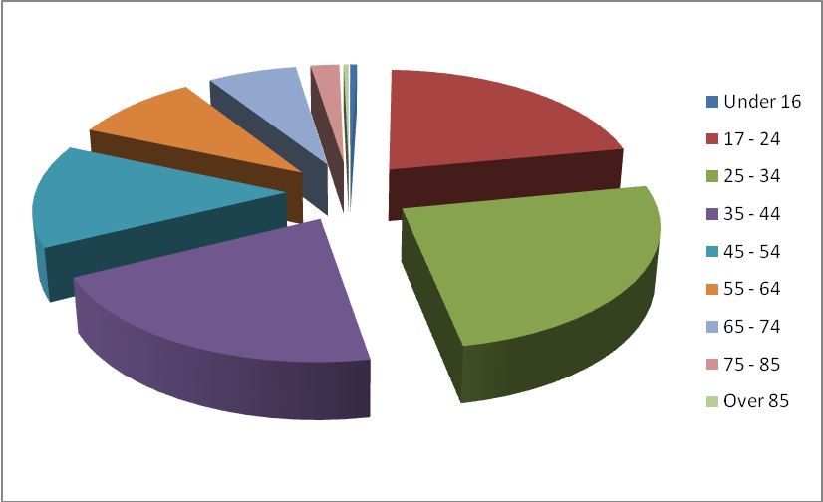

The Practice ensures we engage and recruit by advertising the PRG and virtual PRG via:

- New patient’s registration pack – patients are invited to join the PRG or virtual PRG
at point of registration
- Practice monthly newsletters.
- Websites – www.lockswoodsurgery.co.uk and www.nhs.choices.co.uk
- GP / Nurse / HCA give handouts to patients during their consultations - including chronic disease and baby immunization clinics.
- Posters displayed in the waiting room.
- Opportunist canvassing by the reception team.
- Texting service – targeting ethnic groups and all other areas of the practice the
Population.
- PRG – members spending time in the waiting room canvassing patients and
promoting the PRG and virtual PRG
- Annual Flu campaign – target our older patients the PRG was actively promoted at
the Flu clinics.
- To assist with recruiting our younger population the virtual PRG is promoted at the
vaccination clinics for school leaver as and Warsash college students.
Table 1 - Information checklist for local patient participation report
To validate that the PRG is representative
Practice population profile |  |  |  |  |  |  | PRG profile |  |  |  | Difference
Age percentage and numbers
% Under 16 |  | 17.44% (2363) |  |  |  |  | % Under 16 |  | 0.17% (4) |  | 17.27%
% 17 - 24 |  | 14.67% (1987) |  |  |  |  | % 17 - 24 |  | 8.66% (172) |  | 6.01%
% 25 - 34 |  | 10.39% (1747) |  |  |  |  | % 25 - 34 |  | 14.28% (201) |  | -3.89%
% 35 - 44 |  | 12.90% (2464) |  |  |  |  | % 35 - 44 |  | 9.44% (165) |  | 3.46%
% 45 - 54 |  | 17.72% (2401) |  |  |  |  | % 45 - 54 |  | 4.62% (111) |  | 13.1%
% 55 - 64 |  | 12.17% (1648) |  |  |  |  | % 55 - 64 |  | 4.55% (62) |  | 7.62%
% 65 - 74 |  | 8.81% (1193) |  |  |  |  | % 65 - 74 |  | 4.44% (53) |  | 4.37%
% 75 - 85 |  | 4.73% (641) |  |  |  |  | % 75 - 85 |  | 2.65% (17) |  | 2.08%
% Over 85 |  | 1.17% (158) |  |  |  |  | % Over 85 |  | 1.90% (3) |  | -0.73%
Ethnicity
White |  |  |  |  |  | White
% British Group |  | 98.43% |  |  |  | % British Group |  |  | 10.04% (734) |  | 88.39%
% Irish |  |  |  |  |  | % Irish
Mixed |  |  |  |  |  | Mixed
% White & Black Caribbean |  | 0.07% |  |  |  | % White & Black Caribbean |  |  |  |  | 0.07%
% White & Black African |  | 0.08% |  |  |  | % White & Black African |  |  | 0.01% (2) |  | 0.07%
% White & Asian |  | 0.30% |  |  |  | % White & Asian |  |  | 0.25% (1) |  | 0.5%
Asian or Asian British |  |  |  |  |  | Asian or Asian British
% Indian |  | 0.24% |  |  |  | % Indian |  |  |  |  | 0.24%
% Pakistani |  | 0.02% |  |  |  | % Pakistani |  |  |  |  | 0.02%
% Nepalese |  |  |  |  |  | % Nepalese
% Bangladeshi |  | 0.04% |  |  |  | % Bangladeshi |  |  |  |  | 0.04%
Black or Black British |  |  |  |  |  | Black or Black British
% Caribbean |  | 0.04% |  |  |  | % Caribbean
% African |  | 0.39% |  |  |  | % African |  |  | 0.03% ( 4) |  | 0.36%
Chinese or other ethnic group |  |  |  |  |  | Chinese or other ethnic group
% Chinese |  | 0.35% |  |  |  | % Chinese |  |  | 0.04% ( 5) |  | 0.31%
% Any Other |  | 2.33% |  |  |  | % Any Other |  |  | 7.09% ( 54 ) |  | -4.76%
Gender
% Male |  | 51.32%(69527) |  |  |  | % Male |  |  | 5.44% (378) |  | 45.88%
% Female |  | 48.68%(6594) |  |  |  | % Female |  |  | 6.40% (422) |  | 42.28%
Practice Specific Care groups
All new patients |  |  |  | are invited to join the PPG or virtual PPG at time of registration to the practice - over the past year this would be inclusive of nursing home/ learning disabilities /Carers and other specific groups
Disease prevalence groups at annual checkups COPD , Diabetics , L/D carers , Asthma and CHD |  |  |  | Invited to join virtual PPG and the opportunity to take part in the practice survey at annual review
Baby clinic - staff add hoc canvass this group |  |  |  | Automated booking in system , pick up a practice newsletter and via the practice nurse at review
Patients from ethnic groups |  |  |  | As a practice we have sent text messages to these patients explain what the PRG is and inviting them to join the face to face PRG or join the virtual PRG.
Patients 16 – 30 years |  |  |  | Using the texting service as above
To advertise the PRG in house to all groups |  |  |  | A PRG member has set up a drop in and discuss area in the main waiting room and canvassed patients inviting them to join the PRG group or virtual group, also handing out a patient survey on the new triage system.
Step 2 - Agree areas of priority with the PRG

The 2012 patient survey was reviewed on Thursday 13th December 2012 together with the results of the national GP survey 2012, the practice complaints review and patient’s comments on NHS choices website in order to agree the areas of priority for the 2013 survey.

The priority areas for 2013 were agreed by the PRG and virtual PRG and were:

- Customer care
- Telephone access
- Appointments – covering access / convenience
- On line appointment system
- Overall patients experience at Lockswood Surgery

For our 2014 practice survey we emailed our virtual group in November 2013 for suggestions as to what to include. We also published this in our practice newsletter. An example of the email questionnaire issued to the Virtual Group is below:

Date: November 2013
From: Lockswood Surgery
To: All Virtual Patient Group Members.

PRG latest Survey Results October 2013

The October 2013 survey results are available to view at www.lockswoodsurgery.co.uk/prg.asp

Our priority was to review the appointment structure, customer care and patient experience and to implement changes as required.

We are now planning our next annual survey and to ensure that we ask the right questions, we would like to know what you think should be our key priorities when it comes to looking at the services we provide to you and others in the practice.

Which of the following do you think we should focus on?

- On line appointments
- Telephone triage system
- Telephone access
- How best to communicate with patients

The feedback from this email has been:
Patient education of on line facilities, Review the new triage system, Audit telephone usage since the triage system has been in place, Did not attend – Gp / Nurse appointments and ways the practice communicates with patients ie Flu campaigns.
Step 3 – Collate patients’ views through use of a survey.

At our PRG meeting on 2nd May 2013 the methodology chosen to support the survey was discussed and it was decided that the most effective way to reach as many of the practice population as possible was to email the survey via the virtual PRG. It was also decided to issue 200 surveys to patients at random while they visited the surgery.

The survey questions were agreed by the PRG before publication and reflected the priority areas to be covered. This can be viewed at www.lockswoodsurgery.co.uk/prg.asp

Our survey results were sent to the virtual PRG group in early October 2013 the link was also included in the practice newsletter and remained live for four weeks, to allow for any further feedback.

The outcome of our survey was discussed at the next practice PRG meeting which was held on Thursday 10th October 2013.

Step 4 - Provide PRG with the opportunity to discuss survey findings and reach agreement on change to services

The results of the survey were emailed to the virtual PRG in September 2013 for comment, ready for our practice PRG meeting held on Thursday 10th October 2013. The final survey results were fully discussed and a draft action plan was generated.

All members of the PRG had the opportunity to comment on the survey results and agree the final action plan.

To ensure we informed the wider practice population, a link to the October 2013 survey results was published in the November 2013 practice newsletter and the practice website.

The final version of the 2014 survey action plan is now set and is published on our website as part of this report and in the practice newsletter.

Step 5 – Agree action plan with the PRG and seek PRG agreement to implementing changes

The aim of the 2013 survey was to re-visit previous areas of concern, especially to see if there had been an improvement in the way patients communicated with the practice.

The results of the 2013 survey and resultant PRG discussions generated the following action plan.

LOCKSWOOD Surgery 2013 PRG Survey Action Plan

Area | Action To Be Taken | Timescale
Communications:  Promote online service appointments and repeat prescriptions. Promote the use of texting services.  Ensure mobile and telephone numbers are updated regularly. | For new patients via ‘New Patients’ questionnaire.  Existing patients via practice newsletter, websites , automated booking in system , repeat prescriptions and via reception and clinical staff as necessary.  Regular requests for updates from patients in monthly newsletter. | On going  On going  On going
Communications:  Audit capacity and demand on the telephone system especially early morning. | Capacity and demand audit to be organized. Patient education, triage will mean patients do not have to ring at 8am – has this had a positive effect on telephone access. | June 2014
Communications:  Audit the Telephone Triage System via patient survey. | PRG member will be available in the main waiting room for patient comments and to hand out the survey | February 2014
Communication :  PRG notice board | Part of the main notice board to be given to the PRG | February 2014
Service Delivery:  Choose Patient pathway correctly.  Advertise HCA and the services they can offer | Practice newsletter, website, poster in waiting room  Reception education to assign posting patients to the correct clinics | Ongoing Patient education

Update on 2012 action plan.

The following is a summary of the agreed 20011 Action Plan with updated comments and carry forward activities:

- Promote online service appointments and repeat prescriptions. Promote the use of texting services – Ongoing

- Audit capacity and demand on the telephone system especially early morning - Time scale - April 2014 – 6 months after Triage was introduced

- H& S – Improve lighting on the path to the practice – Bollards and car park security lighting fitted Completed December 2013

- Leaflet in production, to be available on websites and in our main reception area - Completed October 2013

- Re-run practice survey – September – November 2014, completed October 13.

Step 6 – Publicise actions taken - and subsequent achievement

This report will be available on the practice website: www.lockswoodsurgery.co.uk/prg.asp

Practice opening hours and method of obtaining access to services throughout the core hours are:

- Core opening hours are Monday – Friday 08.00 – 18.30

- A patient can access appointments by person and telephone.

- Internet access is available via a secure website 24/7 to book appointments and order repeat prescriptions.

- The practice offers extended access to Gp’s and nurses

Monday 07.30 - 08.00 1 x Gp
Tuesday 18.30 – 19.00 x 3 Gp’s are available each Tuesday
Wednesday 07.30 – 08.00 1 x Gp
Wednesday 18.30 – 20.00 1 x Gp , 1 x Nurse , 1 x HCA
Thursday 07.25 – 08.00 2 x Gp

Saturday 1st & 3rd of the month 08.00 – 10.00 1 x Gp
These are pre bookable appointments, there is no telephone access, appointments can also be booked online.

All GP partners are available for extended hour’s appointments including Saturdays on a rota basis.

Nurses and HCA’s are available Wednesday late evening.

